1.

____T___ a. Kimberly Grant would not appear in the results set.

____F___ b. The GROUP BY clause has an error because the manager_id is not listed in the SELECT clause.

___F____ c. Only salaries greater than 16001 will be in the result set.

____T___ d. Names beginning with Ki will appear after names beginning with Ko.

____F___ e. Last names such as King and Kochhar will be returned even if they don’t have salaries > 16000.

2.

a.

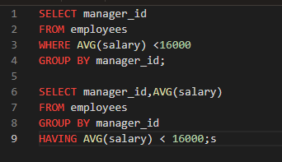

b.

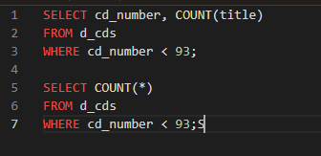

c.

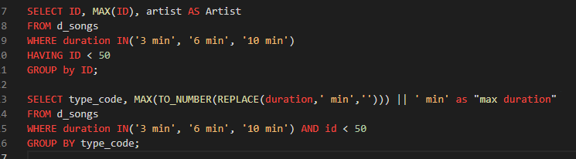

d.

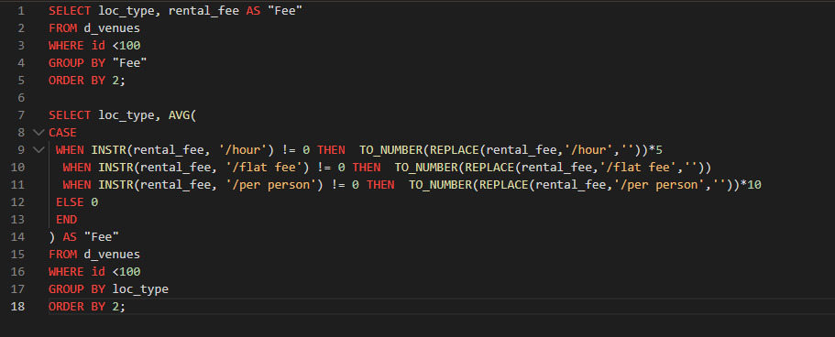

3.

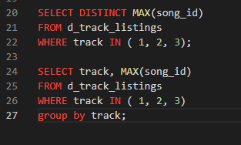

4.

__T___ a. If you include a group function and any other individual columns in a SELECT clause, then each individual column must also appear in the GROUP BY clause.

__F___ b. You can use a column alias in the GROUP BY clause.

__F___ c. The GROUP BY clause always includes a group function.

5.

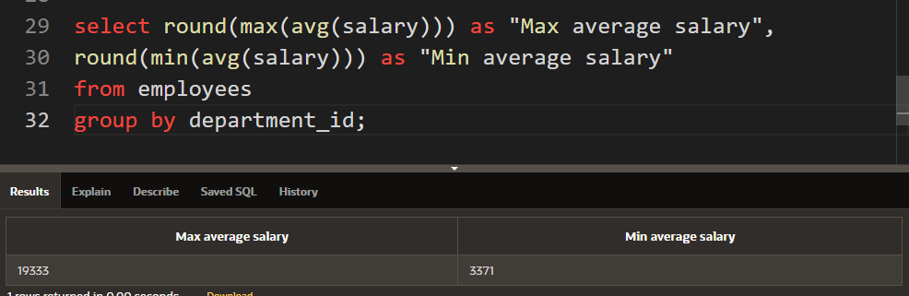

6.

